NSW MPs
Kiama | Gareth Ward  – seat will probably be vacated soon | 102 Terralong Street  KIAMA NSW 2533  (02) 4232 1082  kiama@parliament.nsw.gov.au
Keira  & NSW Health Minister | 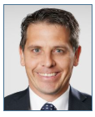  The Hon. Ryan John Park
  Shops 1 - 3
  263 Princes Highway
  CORRIMAL NSW 2518
  (02) 4285 1588
  keira@parliament.nsw.gov.au
  Contact the Minister
Wollongong  & NSW Planning Minister | 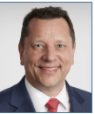  The Hon. Paul Scully | 2/51 Crown Street  WOLLONGONG NSW 2500  (02) 4226 5700  wollongong@parliament.nsw.gov.au  Contact the Minister
Heathcote | 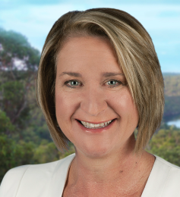  Ms Marryanne Stuart | PO Box 183  ENGADINE NSW 2233  (02) 9548 0144  heathcote@parliament.nsw.gov.au  16th Aug - Drop in outside Coledale Community Hall

Federal MPs
Gilmore | 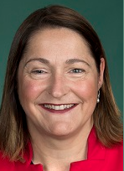  Mrs Fiona Phillips | PO Box 1009  Nowra, NSW, 2541  (02) 4423 1782  contact
Whitlam |   Ms Carol Berry | Shop 244, Stockland Shopping Centre  Shellharbour NSW 2529  (02) 4297 2285  carol.berry.mp@aph.gov.au
Cunningham | 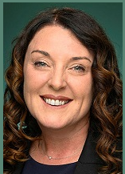  Ms Alison Byrnes
  74 Crown Street
  Wollongong, NSW, 2500
  (02) 4228 5899
  alison.byrnes.mp@aph.gov.au

